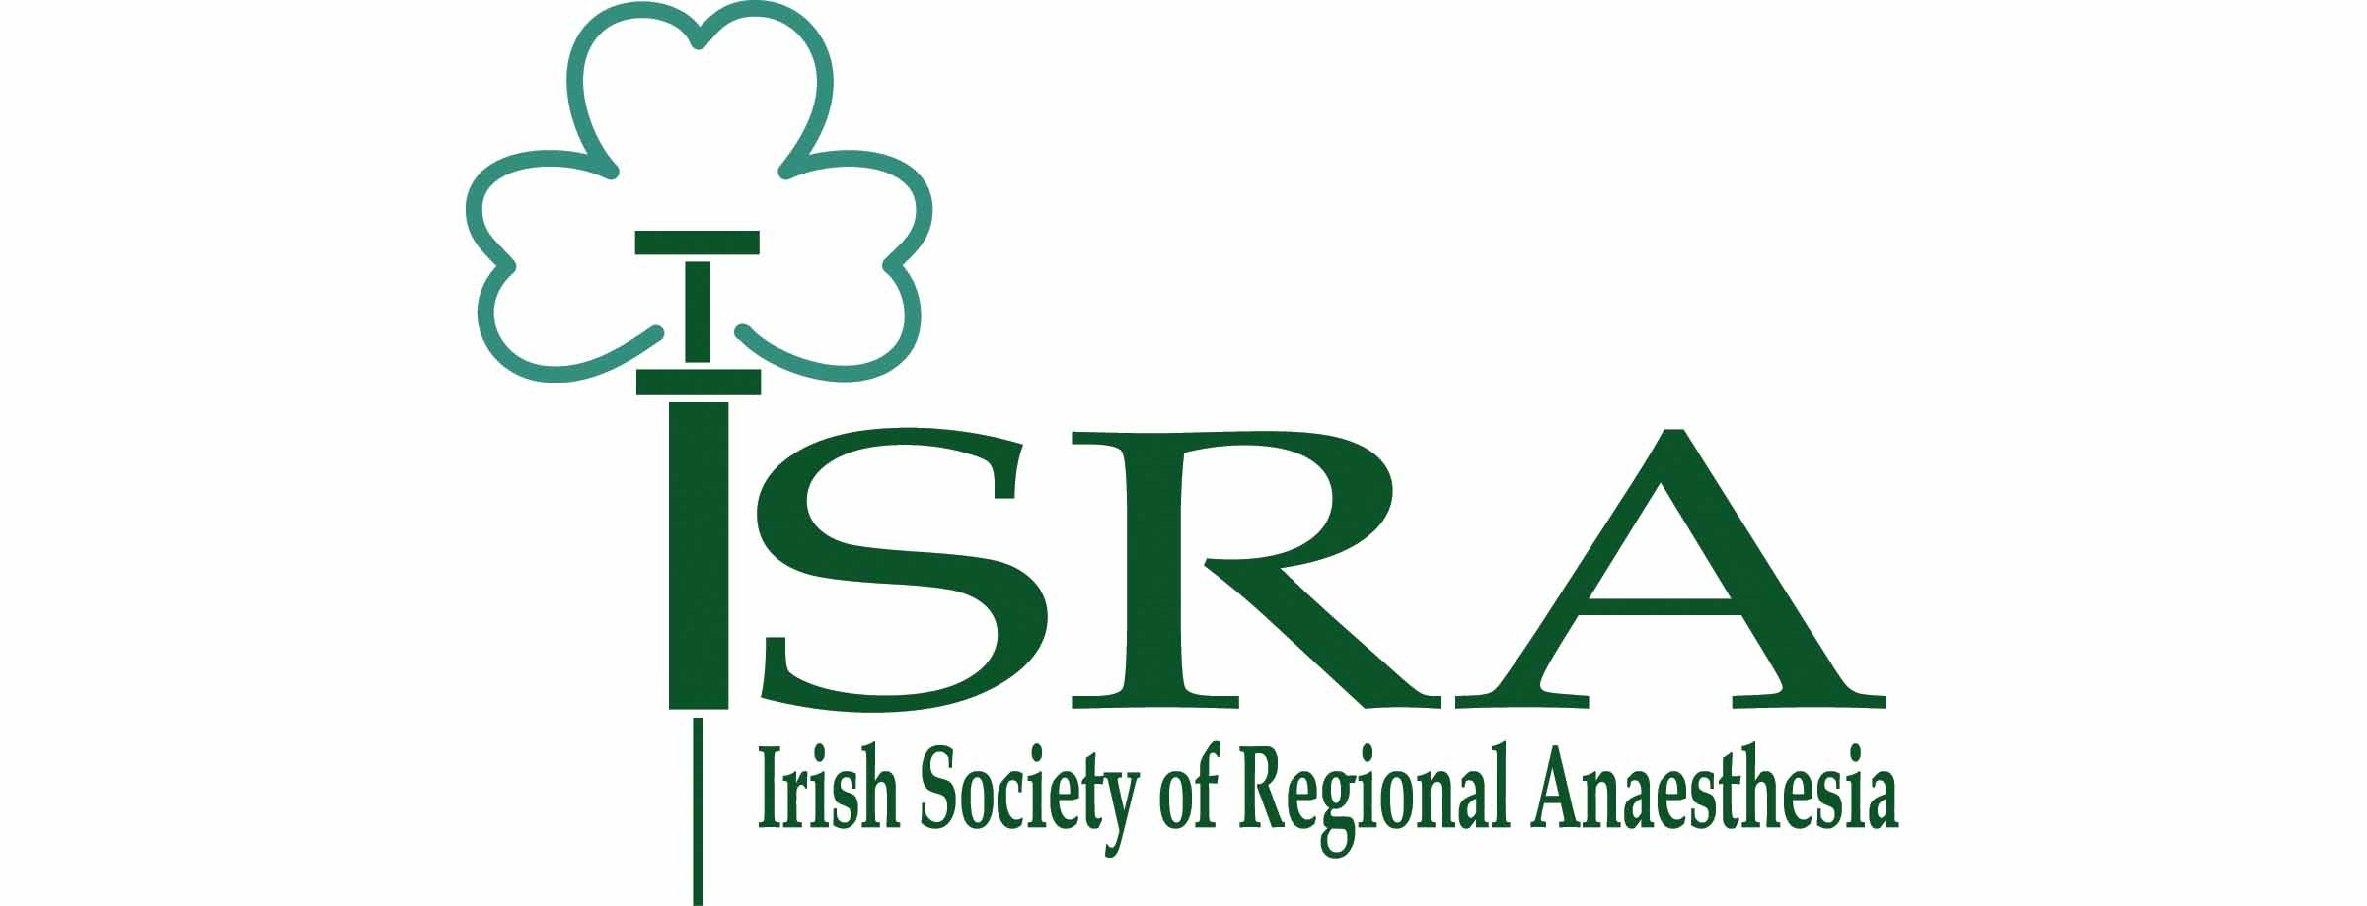
ISRA Update Day 2024
College of Anaesthetists of Ireland, 22 Merrion Square North, Dublin 2.
Friday 19th April
Faculty: Drs David Moore, Conor Skerrit, Ryan Howle, Aneurin Moorthy, Georgi Valchev, Su Ng, Lua Rahmani, Harry Frizelle, Deirdre Edgeworth, Louise Moran, Catherine Nix, Ben Atterton, Kevin Murphy, Paul McHardy (Canada), Steve Choi (Canada), Ahtasham (Canada), Catherine Poots (Belfast), Rosie Hogg (Belfast).
07:45 – 08:20 | Registration & Morning Coffee
08:20 – 08:30 | Introduction from ISRA President | Dr Moore (Dublin)
08:30 – 08:50 | Point-of-Care Ultrasound – Introduction and Accreditation | Dr Hogg (Belfast)
08:50 – 09:10 | USS Guidance for Peripheral Nerve Blockade – Literature Bias | Dr Choi (Toronto)
09:10 – 09:30 | Teaching USS Regional Anaesthesia: Here & Beyond | Dr Niazi (Toronto)
09:30 – 09:50 | Difficult Spinal Anaesthesia – Tips and Tricks | Dr Poots (Belfast)
09:50-10:10 | Regional Anaesthesia in CUH | Drs Atterton/Murphy (Cork)
10:10 – 10:20 | Q&A | All morning speakers
10:20 – 10:40 | Coffee and poster viewing
10:45 - 12:15 | Case-Based Management Demonstrations  - Combination of live RA and PoCUS scanning  - Snapshot updates | 30 min per case  Dr McHardy (Toronto)  Dr Edgeworth (Dub)  Dr Moran (LK)  Dr Poots (Belfast)  Dr Howle (Dub)
12:15 – 12:30 | Q&A
12:30 – 13:30 | Lunch and Sponsor exhibition
13:30 – 16:15  (including 15 min break after end of 3rd workshop) | Workshops  - Proximal Lower Limb blocks  - Phrenic sparing Upper Limb blocks  - TTE – AV assessment  - Lung & Gastric USS (POCUS Portable USS)  - Spinal USS & ESP/PVB | 30 min per station  All Faculty
16:15 – 16:30 | Summary, prize-giving, feedback, and certificates

