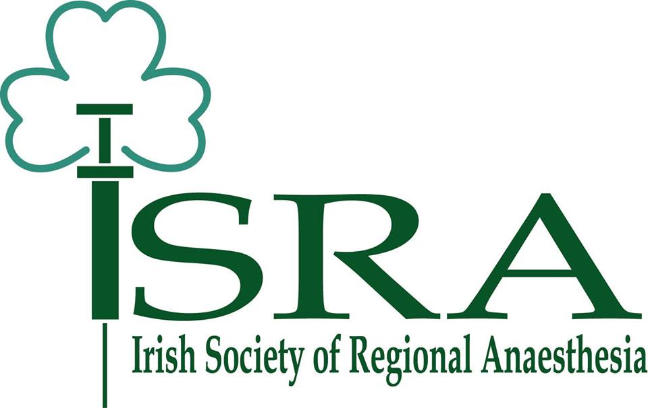

2024 ISRA Research Grant Application

Applicant details (primary investigator)

First name: Click here to enter text.
Last name: Click here to enter text.
Email address: Click here to enter text.
ISRA member: ☐ Yes ☐ No

Head of the research program details:

First name: Click here to enter text.
Last name: Click here to enter text.
Email address: Click here to enter text.
Institution’s name: Click here to enter text.
ISRA member: ☐ Yes ☐ No

Documents to attach
- Applicant’s short CV (include publications, presentations, grants, awards or prizes)
- Academic Mentor / Research supervisor commitment to oversee project
- Study protocol / design including: Short introduction, hypothesis, primary and secondary aims, methods and statistics. 500 words max.
- Research timeline and specific expenses
- Ethics committee approval (if applicable)
- Letter of acceptance (if applicable)

Checklist
☐ Applicant is current ISRA member
☐ Mentor is current ISRA member
☐ Ethics approval
☐ Confirmation of acceptance by publisher / conference
☐ Study protocol / design

Please send your application and all documents via email to isra.secretary@gmail.com.
Application receipt deadline: April 15th 2024 at 23:59

